

**TRANSCRIBE OPTION IS NOT AVAILABLE FOR DESKTOP WORD**



2400 Louisiana Blvd Building 3

Albuquerque, NM 87110

sales@speridian.com

www.speridian.com

Transcribe option is not available in Desktop word this is created with reference of **SPIND/ITS/95913**

Transcribe is the 'speech to text' option in Microsoft Word. It lets you record live or upload an audio file and convert it into text

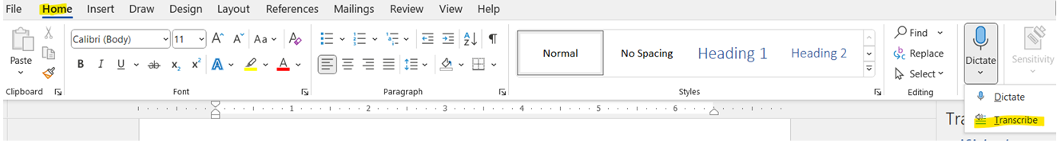

Transcribe option will be present in Home🡪 Dictate🡪Transcribe

**This option will be present only M365 licensed users. It will not be available for standalone applications like office suite 2016 or 2019.**

In Microsoft website they have mentioned Transcribe option will be only for online word not for desktop word but it will be available if we update the office.

Steps to update office

Click on File in home page🡪 and Navigate to account🡪 from there you can see the option to update the office suite. Attaching the screenshot below

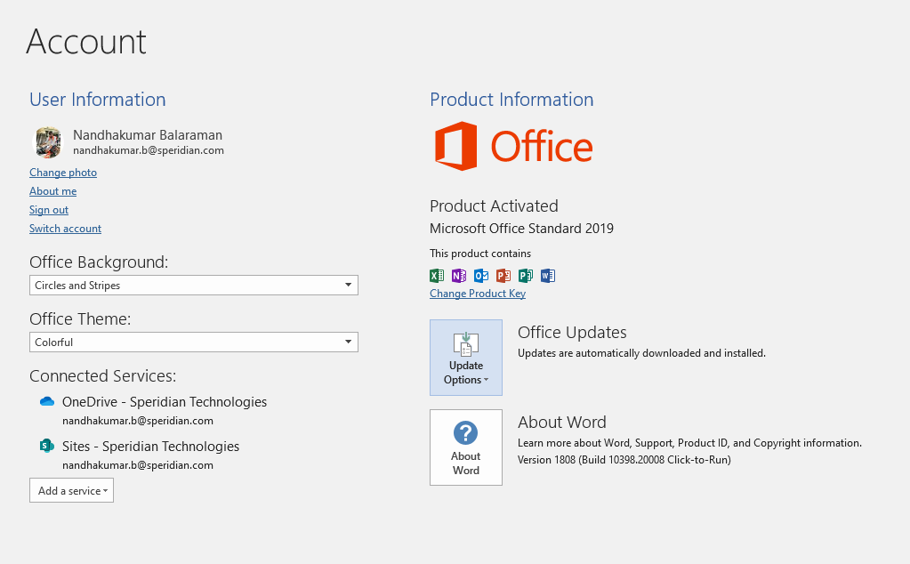

From the above page need to click office updates and update the office.

After updating the office suite. Transcribe option will be available as per below image

